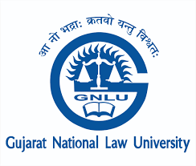

DIPLOMA IN
Ancient Indian Legal Theories & Philosophy
By
Gujarat National Law University, Gandhinagar (GNLU)

PHOTO
ADMISSION FORM

Personal Information
First Name |  | Middle Name |  |  | Surname
Date of Birth |  |  | Sex  - Male  - Female  - Others
Nationality
Category | - GENERAL  - SC  - ST
Address
Street
Postal code
State |  |  | City
Phone no. |  |  | Country
Alternate Phone no. |  |  | E-mail
Details of Employment/Practice/University/Institution/College (for students)

 | Academic Qualification | Degree |  |  | University/Institute | Month and Year of Passing  (Mention Pursuing if still enrolled) |  | Subjects | Marks obtained out of the Total |  | Percentage
Language skills
Please list the languages that you speak:
Language |  |  |  | Write |  |  | Read |  |  | Speak
English
Hindi
Others (Please Mention)

Instructions to Candidates

- Applicants are required to read the Regulations and Eligibility Criteria mentioned on the website of GNLU (Link for the Web Page: Will be put after creating Diploma Webpage on GNLU Website)
- Please use the latest coloured passport-size photograph in the Application form.
- Last date of Application is 30/04/2023 by 05:00 PM.
- Duly filled application along with the enclosures shall be mailed to dailtp@gnlu.ac.in

Enclosures
- An attested photocopy of the Graduation/Post Graduation mark sheet and degree if working professional.
- Proof of enrolment with the College/University where presently studying at if currently a student.

Signature and Name of the Candidate

Date:

Place:

For any further queries, write to dailtp@gnlu.ac.in

